AOMWAY VR GOGGLE V1
USER MANUAL

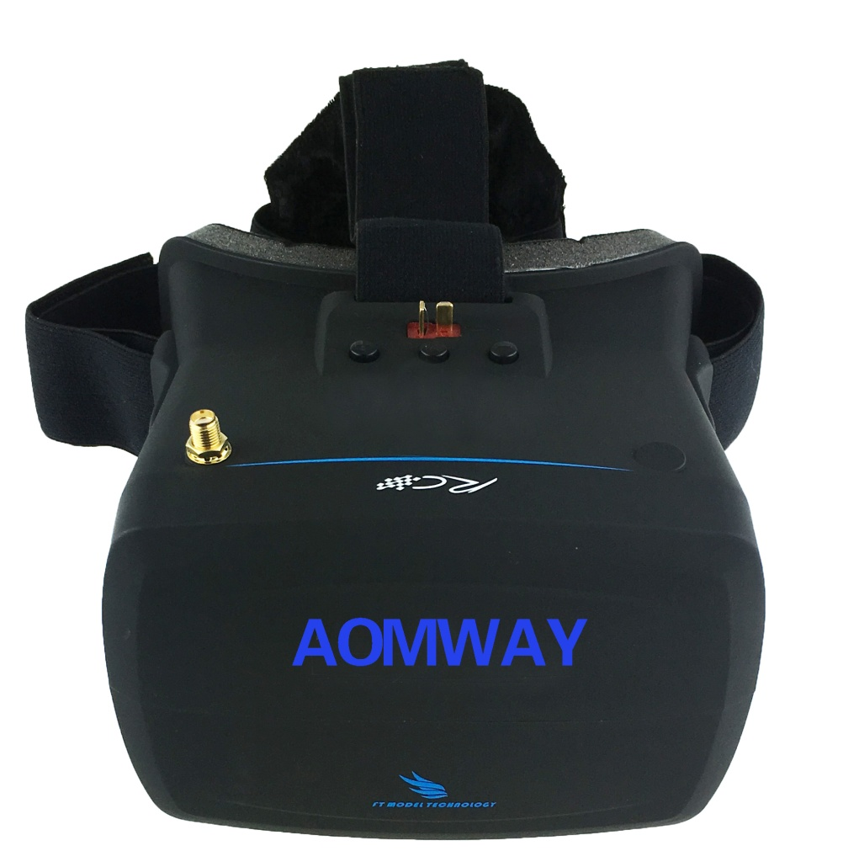

WWW.AOMWAY.COM

- AOMWAY VR Goggle V1
VR Goggle V1 provides FPVers an immersive experience by its 5 inch WVGA (800x480p,16:9) head mounted display, and high-magnification optical lens guarantees clearer vision and larger FOV. NTSC / PAL display format is auto detected, display contrast and brightness are adjustable by pressing the top button, a 5.8GHz 40CH receiver of high sensitivity already built in and user can do one key auto channel scan with this goggle, extremely easy to use. It comes with multi-interfaces like AV in, AV out and earphone jack to cover all you needs.

- Product Specifications
- Power Supply: 7-17v(2S-4S,OSD display voltage status)
- Working Current: 300mah
- Display: 5 inch TFT screen
- Resolution: WVGA 800x480p
- Display Ratio: 16:9
- Format: Auto select NTSC/PAL
- OSD menu: One key display CH and battery status on screen
- Receiver: Built-in high sensitivity 5.8Ghz,40CH Receiver
- Frequencies:

CH1 | 5.645GHz | CH2 | 5.658GHz | CH3 | 5.665GHz | CH4 | 5.685GHz | CH5 | 5.695GHz
CH6 | 5.705GHz | CH7 | 5.725GHz | CH8 | 5.732GHz | CH9 | 5.733GHz | CH10 | 5.740GHz
CH11 | 5.745GHz | CH12 | 5.752GHz | CH13 | 5.765GHz | CH14 | 5.769GHz | CH15 | 5.771GHz
CH16 | 5.780GHz | CH17 | 5.785GHz | CH18 | 5.790GHz | CH19 | 5.800GHz | CH20 | 5.805GHz
CH21 | 5.806GHz | CH22 | 5.809GHz | CH23 | 5.820GHz | CH24 | 5.825GHz | CH26 | 5.828GHz
CH27 | 5.840GHz | CH28 | 5.843GHz | CH29 | 5.845GHz | CH30 | 5.847GHz | CH31 | 5.860GHz
CH32 | 5.865GHz | CH33 | 5.866GHz | CH34 | 5.880GHz | CH35 | 5.880GHz | CH36 | 5.885GHz
CH37 | 5.905GHz | CH38 | 5.917GHz | CH39 | 5.925GHz | CH40 | 5.945GHz

- Operation: Auto scan CH / manually select CH / contrast & brightness adjustment
- Working Environment: -20°C-80°C
- Interface:
- Earphone jack
- AV in
- AV out
- Standard DC T-type plug(with battery extension cable)
- Size: 168x158x105mm
- Weight: 258g

- Attention
- Please avoid dropping or severe impact or violent shaking of this product, otherwise it will cause display damage or malfunction.
- Please avoid using this product under extremely cold or severe heat or dusty or humid environments; pay extra attention when using under the below environments:
  - At a place that is full of dirt and dust;
  - At a place that easy to contact water such as raining weather or beach.
- In need of long working period, we suggest use to take a break after 30mins of use; in case you have a uncomfortable feeling, please stop use the VR goggle immediately, if it is necessary please seek medical aid;
- If the goggle lens gets dirty, please use a cloth made of cotton material for clean-up;
- For long time storage, please put it away under a dry environment with good ventilation. After a certain period, you need to plug the power on for checking its condition.

- Operation
- Shortcut Mode:
- Press ‘+/ -’ to adjust display brightness (each press adjust 10%);
- Long press ‘Menu’ to start auto scan channel;
- Short press any button to trigger voltage level and current channel to display on screen;
- Full Menu:
- Manual Selection of Channel: short press ‘Menu’ button to display menu on screen. 5654 to 5945MHz (40 channels in total) all set in sequence, press button ‘+/-’ to select wanted channel. Long press ‘+’ and ‘-’ together to enter shortcut mode;
- Auto Scan Channel: press ‘+’ and ‘-’ together to start high speed auto scan channel;
- Brightness Adjustment: press button ‘+/-’ to adjust brightness, long press ‘+’ and ‘-’ together to enter into fast change mode;
- Contrast Adjustment: press button ‘+/-’ to adjust contrast, long press ‘+’ and ‘-’ together to enter into fast change mode;
- Chroma Adjustment: press button ‘+/-’ to adjust chroma, long press ‘+’ and ‘-’ together to enter into fast change mode.

- Interface
- AV in: when plug on AV cable with video source, system will auto detect and switch display mode;

- AV out: 3.5mm 4-pole AV jack, yellow for video, red & white for audio, and shielding line for ground.
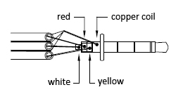
- Audio: 3.5mm 3-pole earphone jack

- Package Contents:
- 1 x VR Goggle V1
- 2 x Facial Foam (1pcs thin foam, 1pcs thick foam)
- 1 x Head Strap
- 1 x 5.8 GHz Dipole Antenna
- 1 x Battery Extension Cable
- 1 x Earphone Extension Cable

