Jumper FPV Headband display
JP-VR7 FPV Headband display is designed for FPV crossing design, using ultra-low latency of 800 * 480 screen, with the grading receiving module, image signal a more direct and more smoothly.
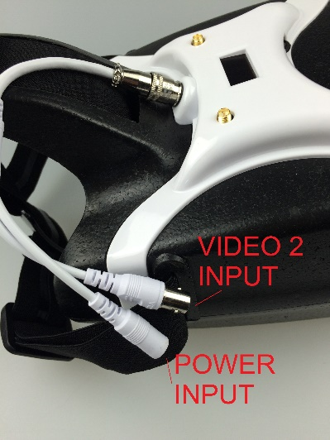
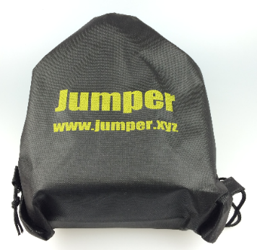
Display Specifications
Resolution：800*480
Perspective：70°
Dial-up menus to adjust
Screen Delay ：5ms

Basic Specifications Features
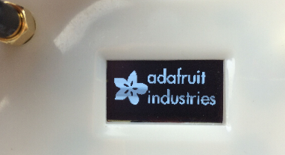
Dial buttons
Adjustable elastic energy

Power input
Power consumption：300ma@12v
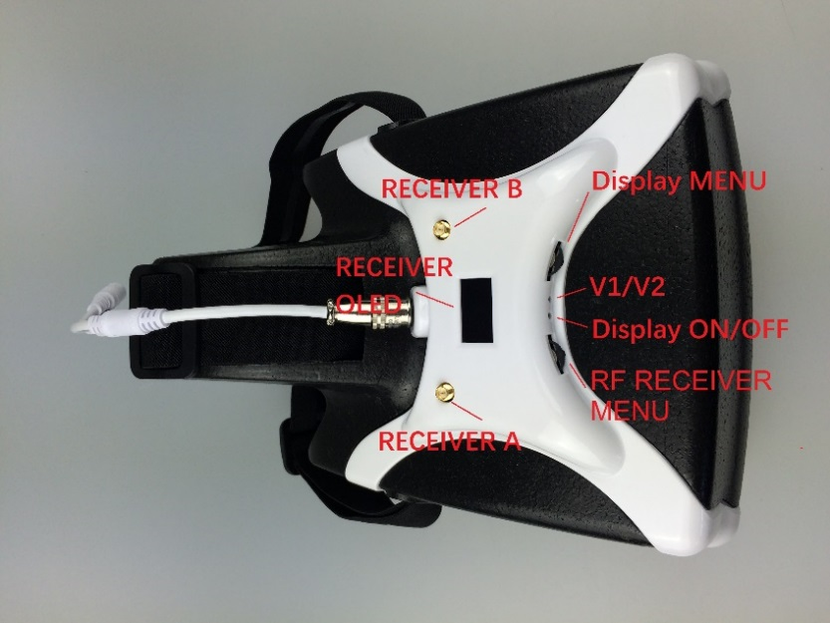
Operating Voltage：7-25v（2s-6s）
RF Receiver
40-channel receiver grading 5.8g
(double receiver module)
