Screens
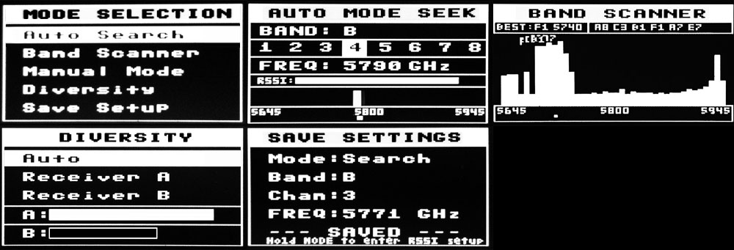
- Mode Select - Use the up/down buttons to navigate. Hit mode to select. Don't press anything to return to the last mode selected.
- Auto Scan - Scans all bands until a signal with good signal strength is found.
- Manual Mode - Will hold on a manualy selected channel.
- Band Scaner - Scans all bands and presents them with a sitnal strength bar graph.
- Diversity - Select which receiver to use or auto. Also Displays signal strength of each antenna.
- Setup Menu - Saves last used channel and mode for next power cycle. This is also where you enter RSSI calibration mode.
  - ORDER - Change the Manual Mode channel seek order by frequency or channel number.
  - BEEPS - Turn beeps on or off.
  - SIGN - Edit your call sign. ( OLED Only )
  - Calibrate RSSI - Calibrate the min and max RSSI values.
  - Save & Exit

Initial Setup
When powering on for the first time it is best to calibrate your RSSI modules. No two modules have the same RSSI min and max readings. To calibrate follow these steps below. You can repeat this process as many times as needed.
- Power on your receiver and transmitter and place them about 5 to 20 feet apart from one another. (For best results remove antennas to calibrate each module on a level playing field.)
- Next navigate to the "Setup Menu".
- Next navigate to "Calibrate RSSI".
- Now that you are in the RSSI calibration screen, the receiver will scan all channels 3 times getting the min and max RSSI strength.
- Once all 3 scans are complete you will be returned to the last home screen. You should now be able to have accurate RSSI readings and also auto scan to active channels.

